**Chapter 4(Root Finding)**

**[will be added]**

**Chapter 5(Linear System)**

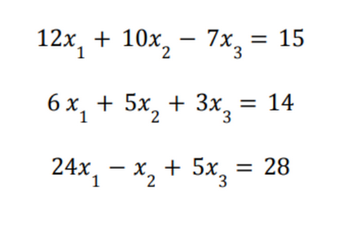

**Q1) Using the above equations**

i) Construct the A, x and b matrix from the above linear equation set

ii) Using the above equation, use **Gaussian Elimination** to find the solution of the system.

**Q2) Using the above equations**

i) By calculating the row multipliers, m, find A(2)

ii) Find F(2)  and A(3)

iii) Find L and U

iv) Find the solution of the system.

**Chapter 7(Integration)**

**Q1) For the following equations with interval [-1,4], find:**

1. e5x  + 5x
2. 6x - e-2x
3. 5x2  + e-1x
4. sin(2x+3)
5. cos(5x)

i) Actual integral value

ii) Evaluate n=1 (nodes =2) with closed Newton Cotes formulae (Trapezium Rule). Also find absolute and relative error.

iii) Evaluate n = 2 (nodes = 3) with closed Newton Cotes formulae( Simpson Rule). Also find absolute and relative error.

iv) Find approximate integral using Composite Newton Cotes formulae using C1,3 , C1,4 , C1,5 , C1,5  . Also find absolute and relative error for each case.

**Chapter 6(Integration)**

**Q1) Consider a system where f(2)=5 , f(1)=9, f(7)=2, f(4)=0. Using this, find the best fit linear polynomial.**

i) Show the values in equation format

ii) Find A, x and b

iii) Using the Gram-Schmidt process, find the orthonormal columns q1 and q2.

iv) Construct Q.

v) Find matrix R

vi) Find matrix x

vii) Find the best fit linear polynomial

**Q2) Consider a system where f(2)=5 , f(1)=9, f(7)=2, f(4)=0. Using this, find the best fit quadratic polynomial (degree = 2).**

i) Show the values in equation format

ii) Find A, x and b

iii) Using the Gram-Schmidt process, find the orthonormal columns q1 and q2.

iv) Construct Q.

v) Find matrix R

vi) Find matrix x

vii) Find the best fit linear polynomial